Global AI Job Market & Salary Trends 2025

1. Project Overview and Objective
- This Project Involves Analysing The AI Job Market Using Excel And Power BI. The Data Provides Details About Job Titles, Experience Levels, Employment type, Company location, Salary, benefits.
- The main objective is To Derive Meaningful Insight IN to Salary Trends, Experience Distribution, Remote Work Ratios, And Hiring Patterns Across Countries.

2. Data Sources
- Source Description and Timeline: Data Collected From Kaggle (Global Ai Job Market & Salary Trends,2025).
- Domain: Job Market / HR Analytics /

3. Problem Statement
- To Analyse Global Ai Job Market Trends And Gain Insights Into Salary Distribution, Employment Types, Experience Levels, And Remote Work Preferences.
- To Identify Top-Paying Countries And Job Titles Within The AI Domain.
- To Understand How Experiences And Employment Type Affect Average Salaries And Benefits
- To Evaluate Overall Job Distribution And Benefits To Understand The Demand And Opportunities In The AI Job Sector

4. Attribute (Column /Features) Details:
Attribute Name | Data Type | Description
Job ID | String | Unique identifier for each Job Record
Job Title | String (Text) | Title Of The AI Related Job Role
Salary | Numeric (Integer) | Salary Offering In USD
Experience Level | Categorical | Level Of Experience(Entry, MID, Senior )

5. Tools & Technologies
- Excel: Data cleaning, transformation, and Pivot Tables.
- Power BI: Data modelling, DAX calculations, visualization, and interactive dashboard creation.

6. Data Pre-Processing (Excel / Power Query)

Tasks Performed:
- Data Cleaning & Transformation: Removing Duplicate And Null Entries From The Data Set, Standardized Column Names And converted salary data into numeric format.
Handled missing values in Benefits Score and Remote Ratio columns.
- Filtering & Sorting: Filtered records by relevant job categories.
- Pivot Tables: Generated Pivot Tables for data summarization and initial insights.
- Created calculated columns for average salary and experience-based segmentation.

7. Data Modelling and DAX (Power BI)
- Data Model: Established relationships between tables, defined cardinality, and created lookup tables where necessary.
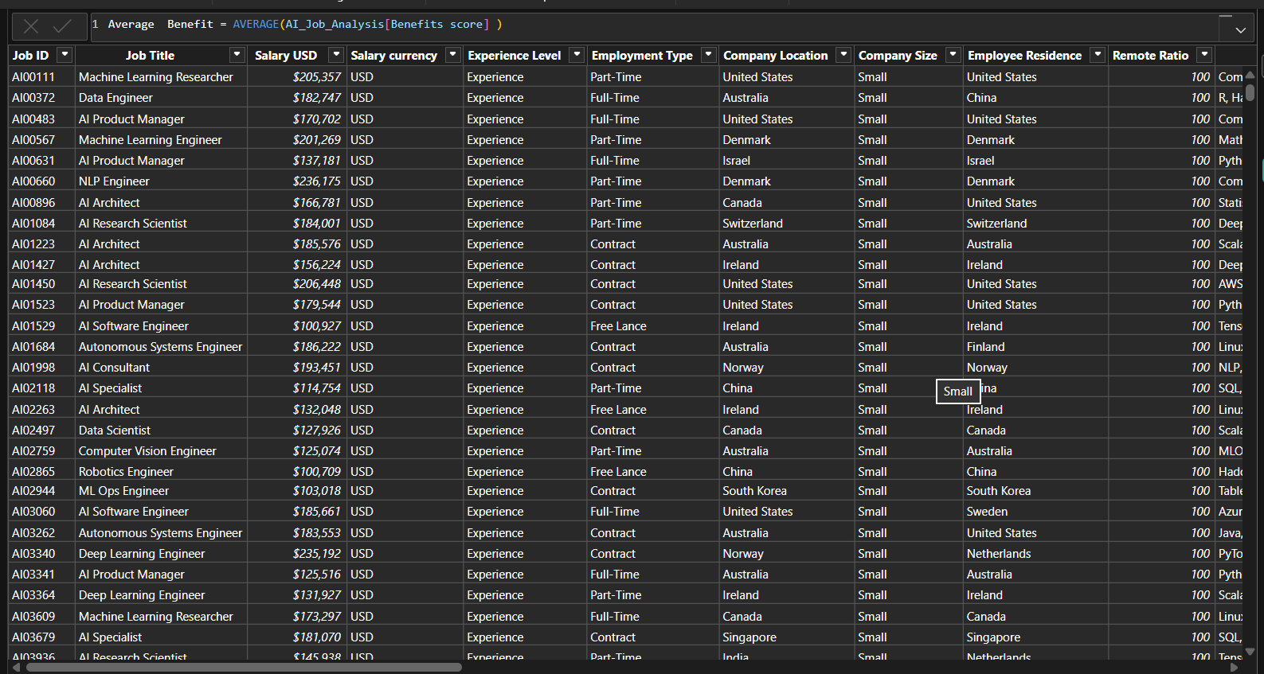

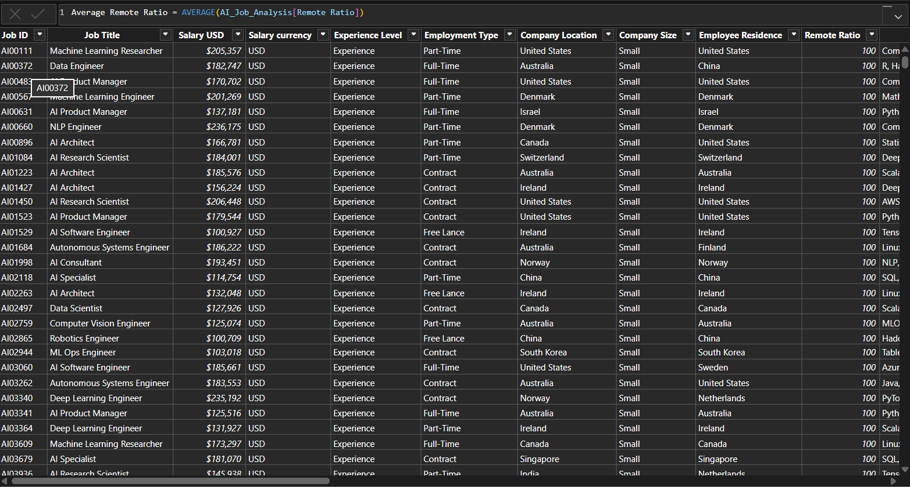

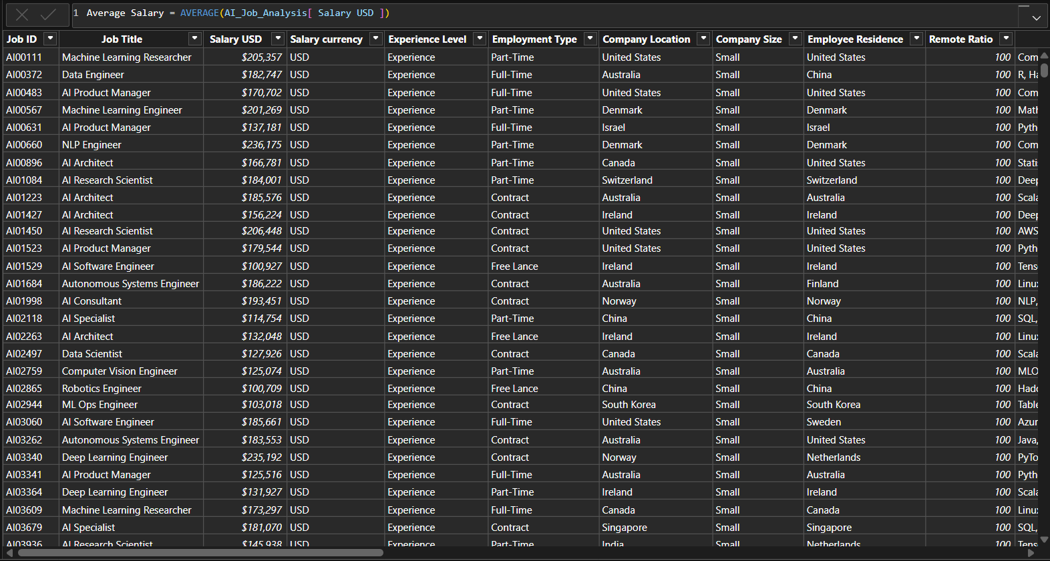

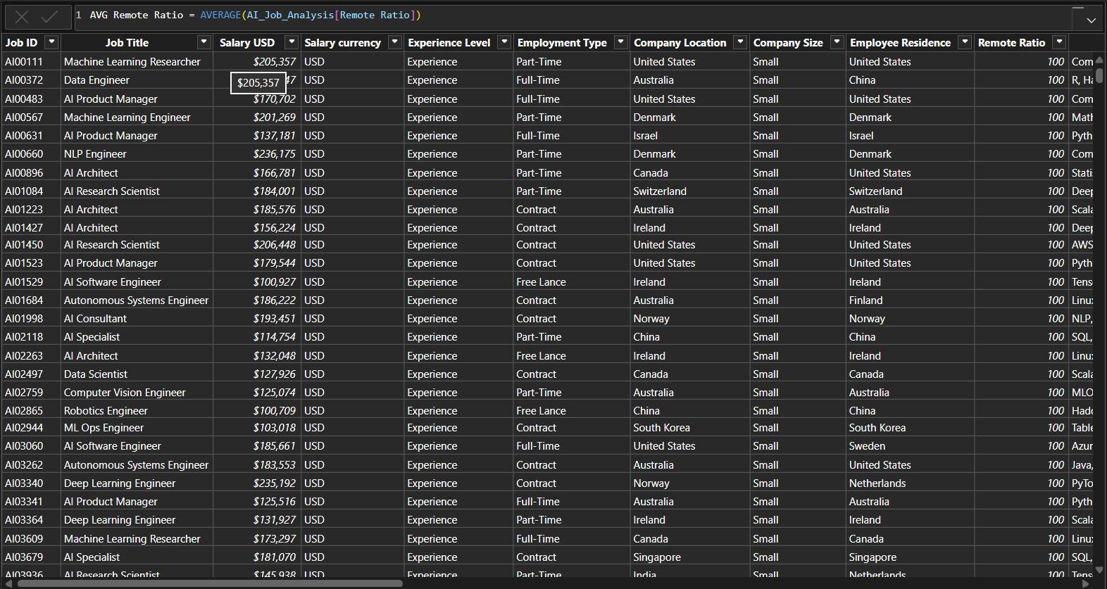

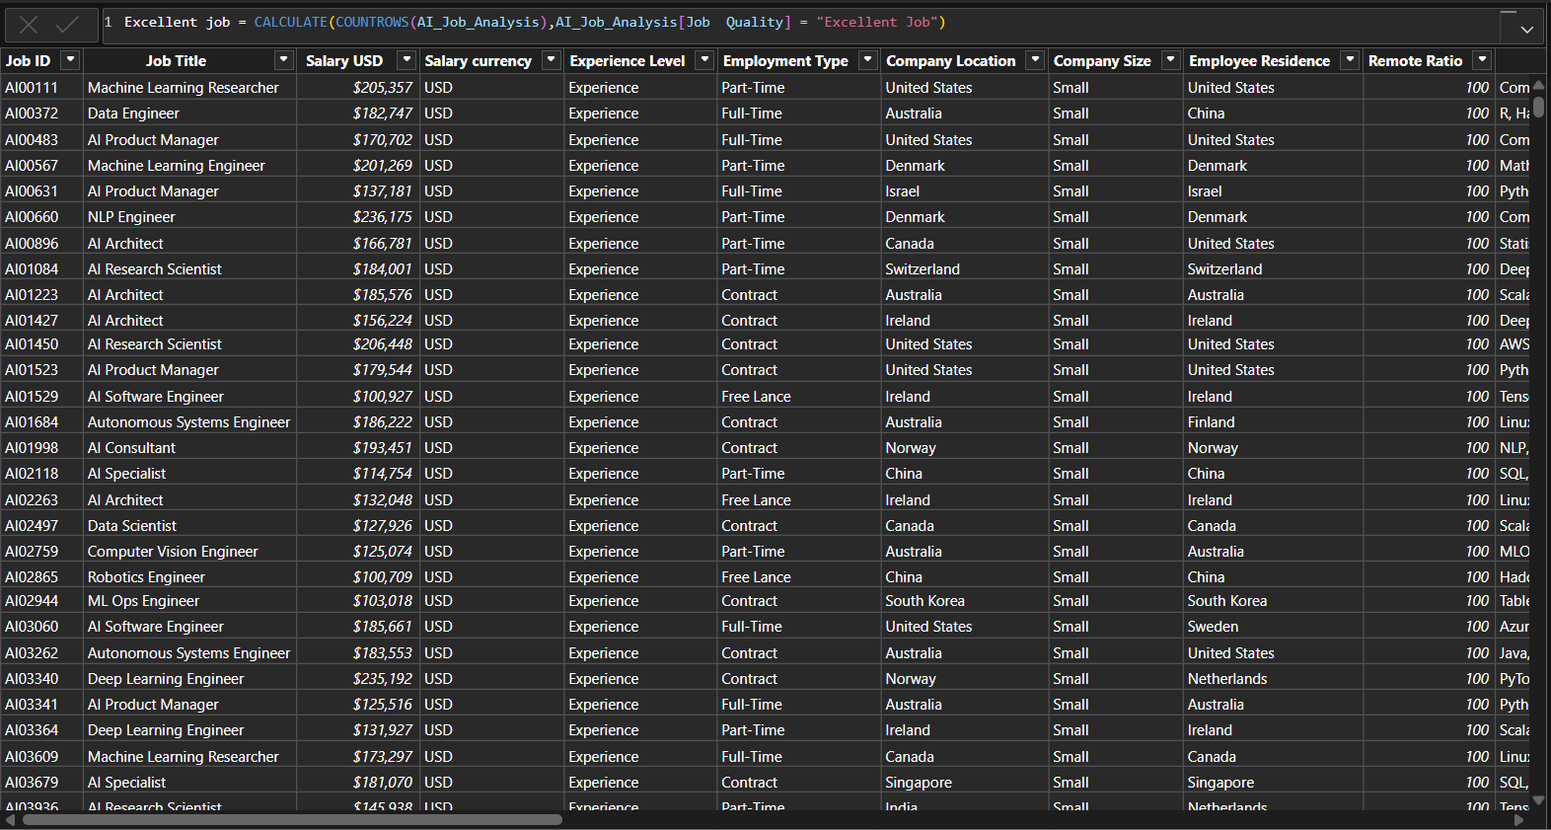

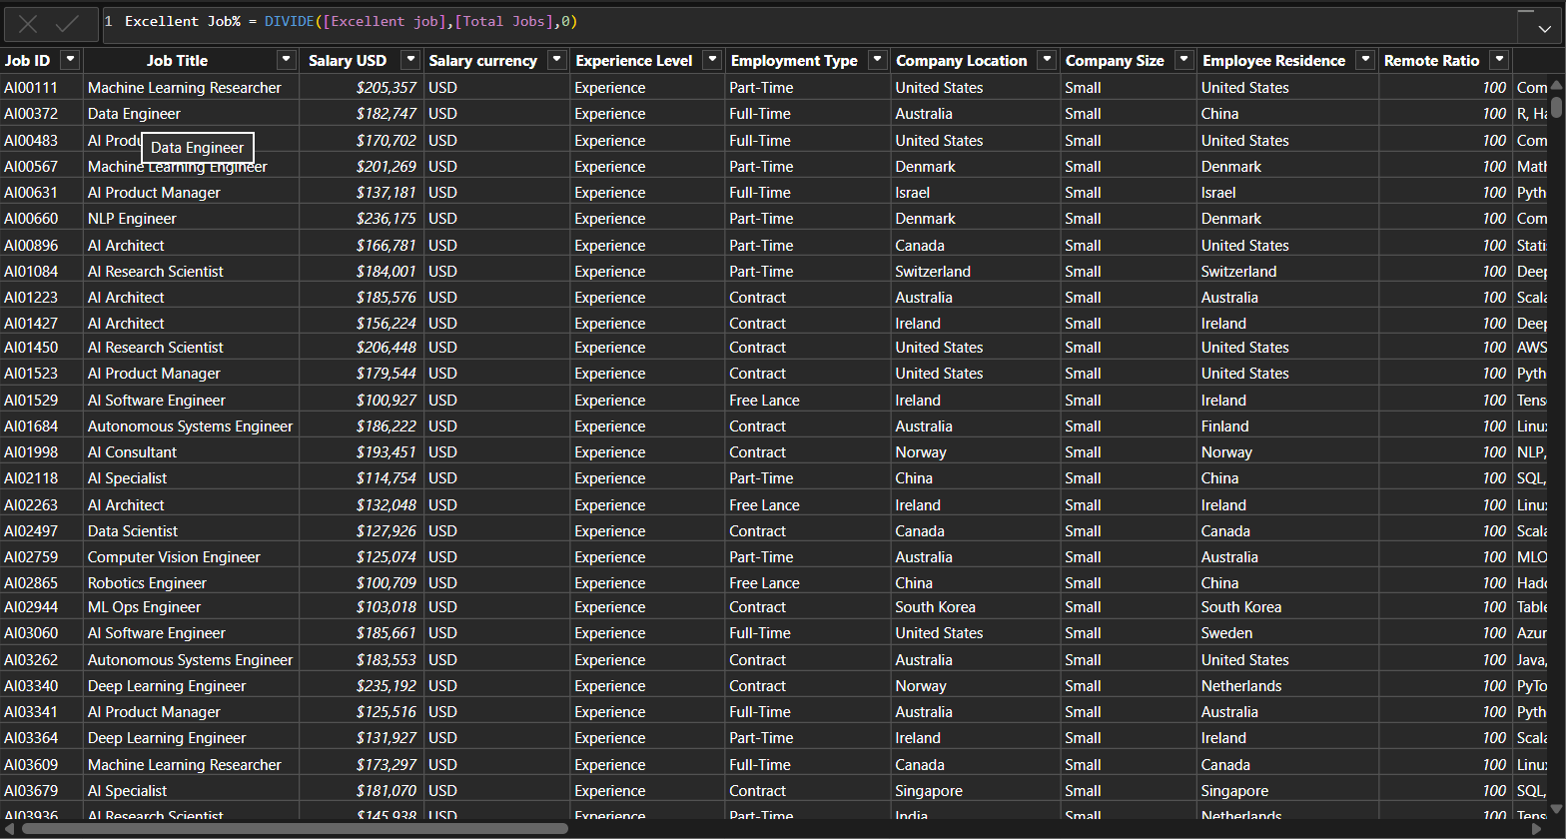

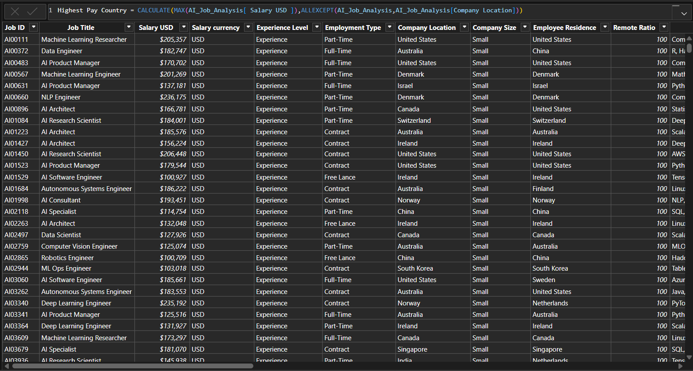

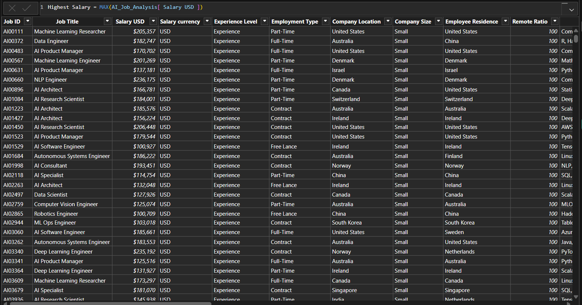

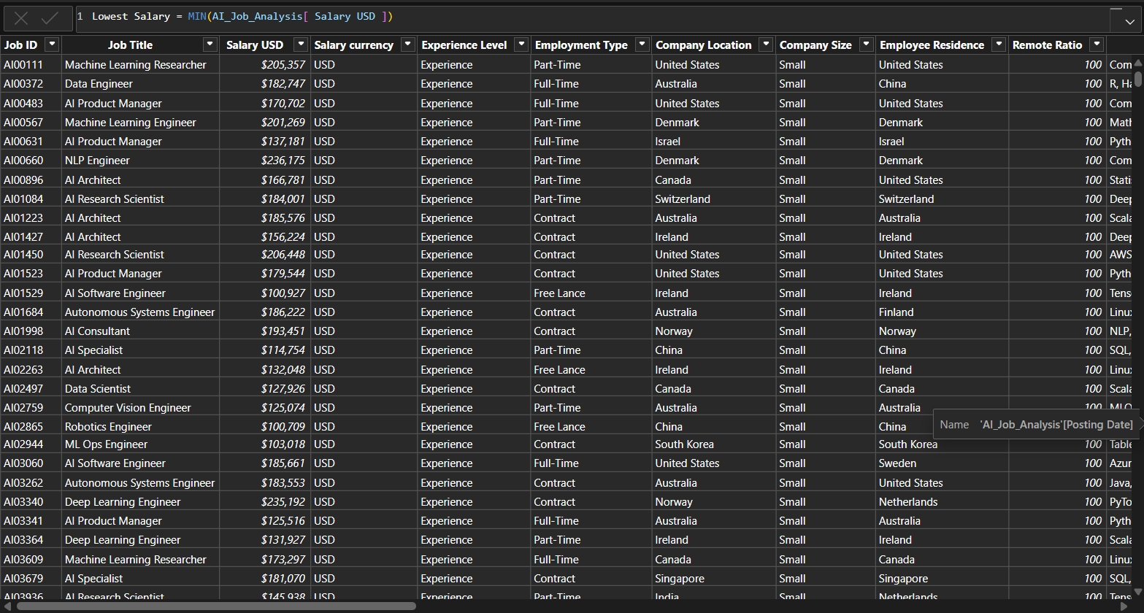

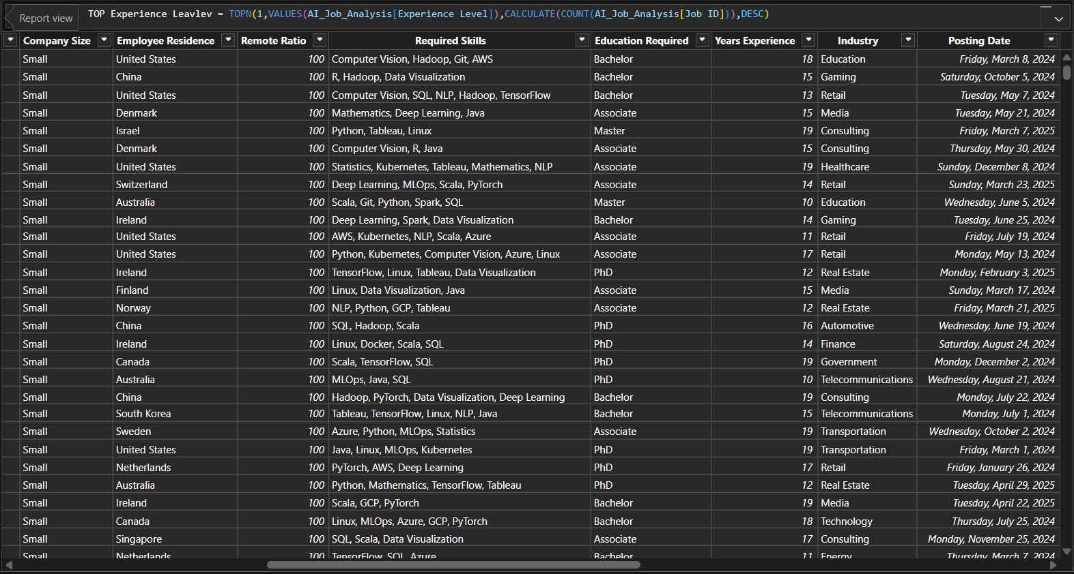

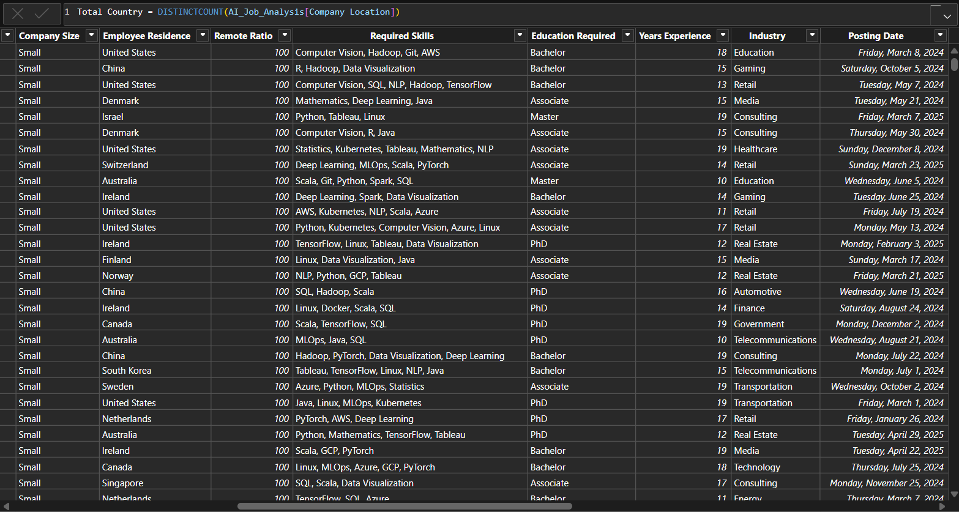

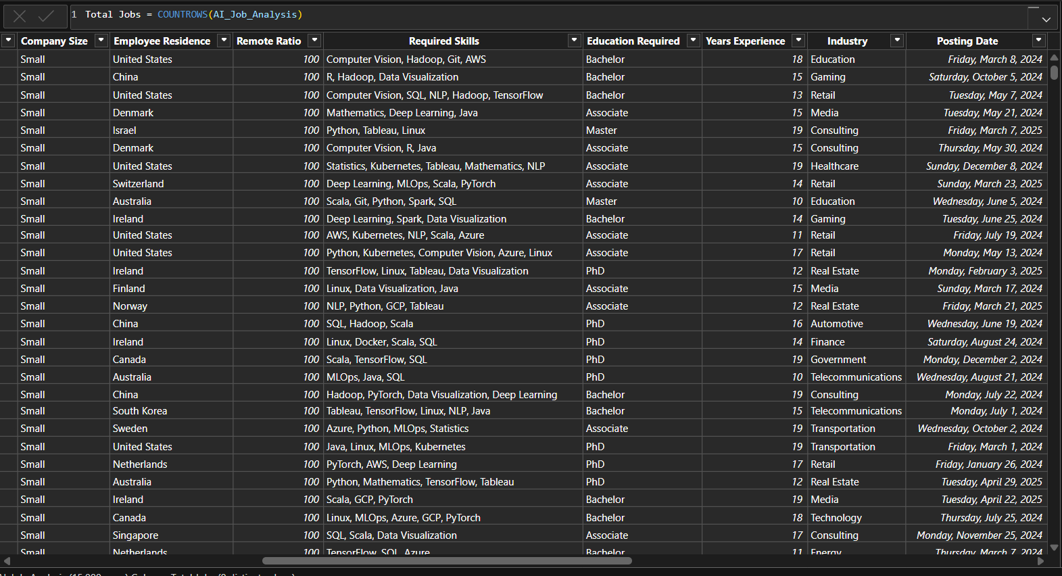
- Calculated Columns & DAX Measures: Implemented DAX formulas for key metrics, such as total sales, growth percentages, and cumulative totals. (List Out)

8. Analysis and Visualizations (Power BI)

Dashboard Features:
- Multiple Visualizations based on problem statement: Bar charts, line charts, pie charts, cards, and tables to communicate insights. (List Out)
- Make your Report interactive Layout using Drill-down, Filters and slicers
- Bookmarks, Clear Titles for each visuals & Labels is must.
- Create a consolidated Report .
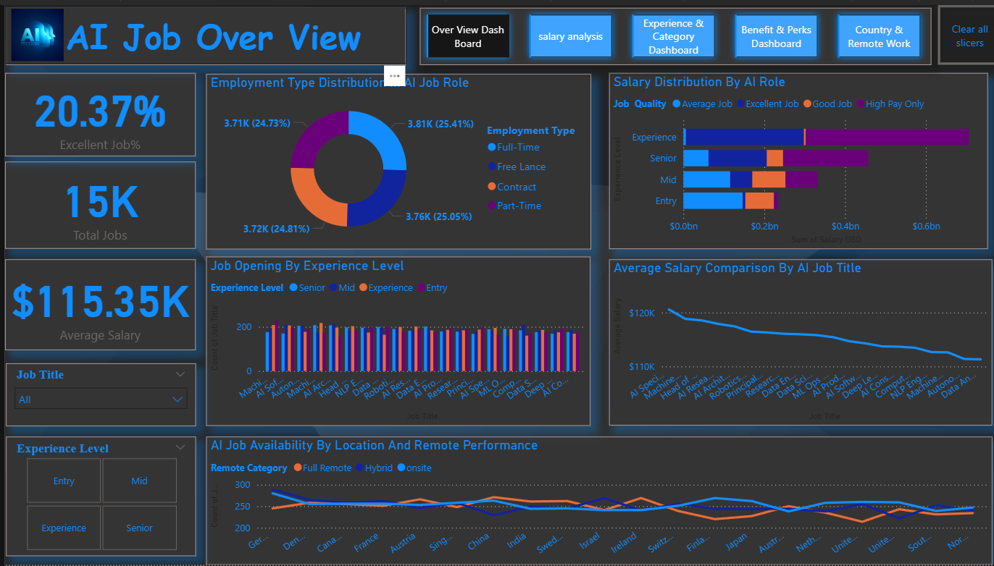

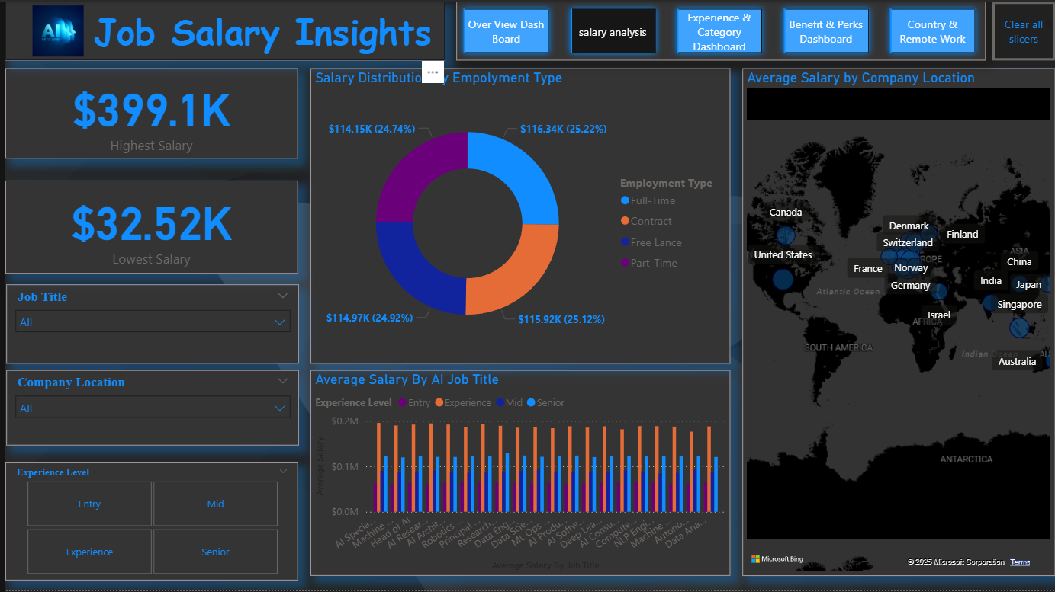

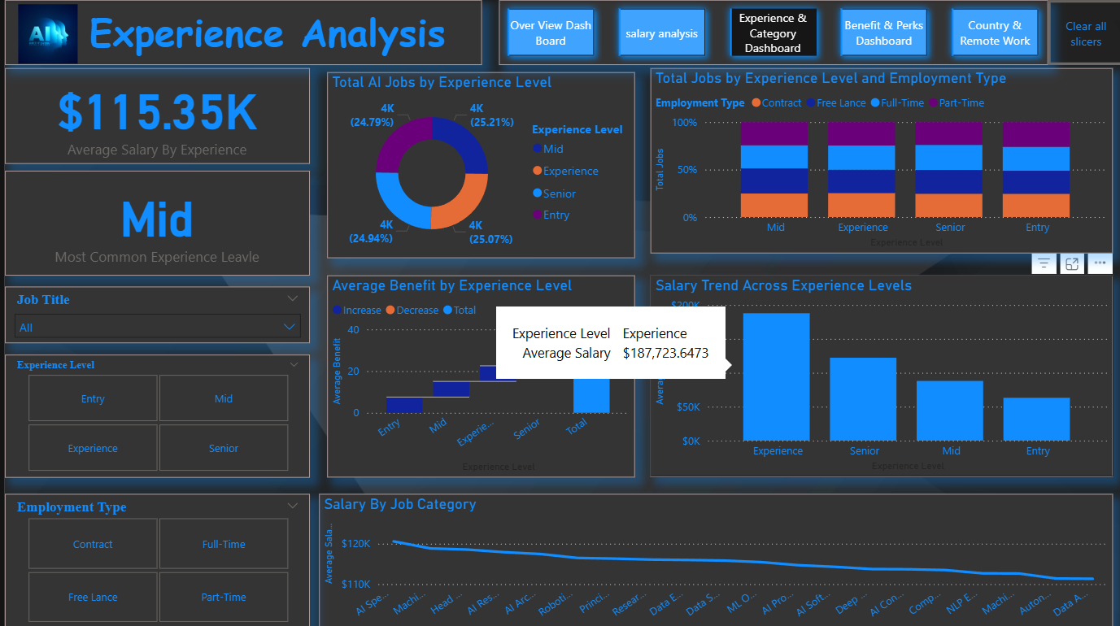

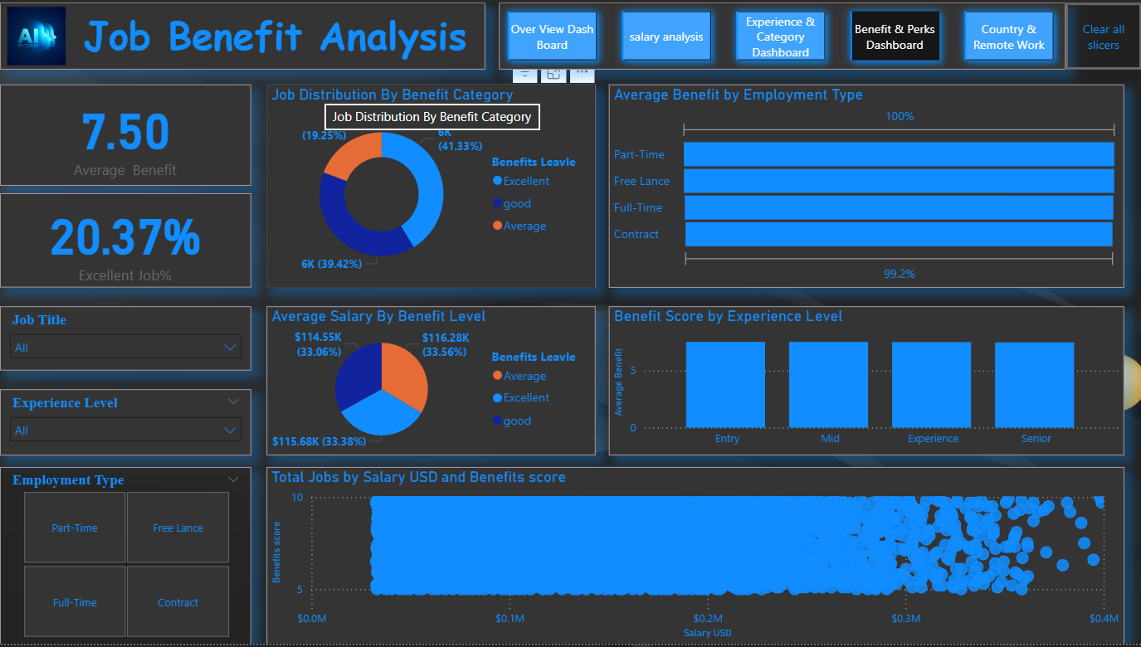

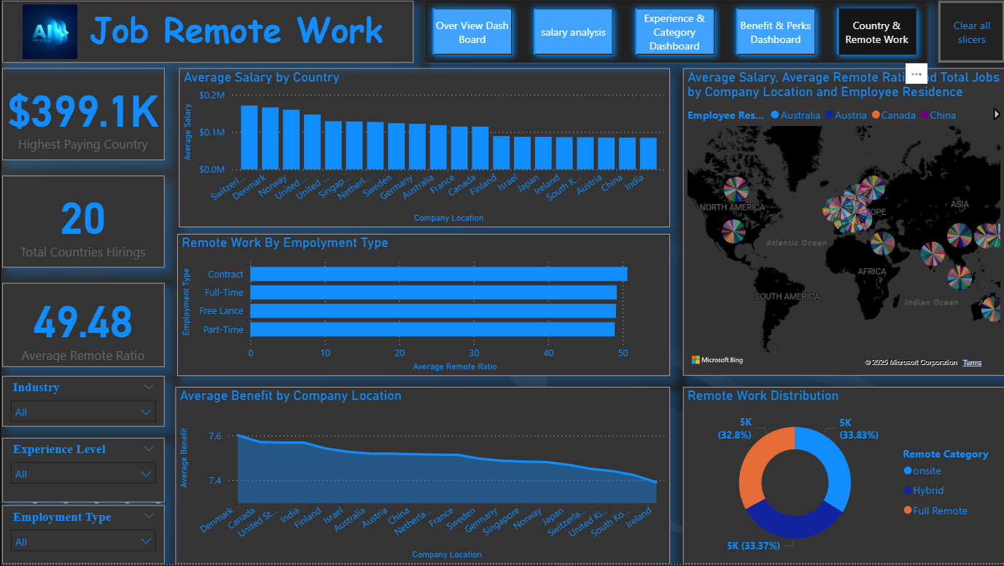

9. Insights & Conclusions
- Key Findings: Summarize trends, patterns, or anomalies identified in the data
- Provide the analysis insights:
    - Descriptive
    - Diagnosis
    - Predictive
    - Prescriptive
10. Conclusions
The integration of Excel and Power BI proved effective in deriving insights from large-scale job datasets. Through visual analysis, this project helped identify salary trends, top-paying countries, and the relationship between experience and job quality. The findings can assist job seekers and HR professionals in understanding AI job market trends and making data-driven decisions.

